

**WELCOME TEST**

**SECTOR: ICT**

**TRADE: SOFTWARE DEVELOPMENT**

**RTQF LEVEL: III A ,B & C**

**MODULE CODE AND TITLE: SWDWD301- WEBSITE DEVELOPMENT**

**DURATION: 3 Hours**

**DATE:07/01/2025**

**TIME :08H30-10H30**

**NAMES………………………………………………………………………**

1. **What does HTML stand for?**
2. Hypertext Markup Language
3. Hypermedia Transfer Language
4. Hyperlink Text Markup
5. Hypertexting Markup Language
6. **How do you create a bulleted list in HTML?**
   1. **Use the <ul> tag**
   2. **Use the <ol> tag**
   3. **Use the <li> tag directly**
   4. **Lists are not supported in HTML**
7. **What attribute specifies the alternative text for an image?**
8. **alt**
9. **src**
10. width
11. height
12. **Which tag defines a heading in an HTML document?**
13. <h1> to <h6>
14. <head>
15. <title>
16. <p>
17. **How do you specify the background color of a webpage in HTML?**
18. Use the bgcolor attribute on the <body> tag
19. Use the <style> tag with the background-color property
20. Use the <color> tag
21. Background colors are not supported in HTML
22. **What is the difference between an attribute and a tag**
23. Attributes provide additional information to tags, while tags define the structure of the document.
24. There is no difference between attributes and tags
25. Attributes are used for styling, while tags are used for content
26. Tags are nested within attributes.
27. **Which program is used by web clients to view the web pages?**
28. Web browser
29. Protocol
30. Web server
31. Search Engine
32. **What is the name of the location address of the hypertext documents?**
33. Uniform Resource Locator
34. Web server
35. File
36. Web address
37. **What is the correct syntax of doctype in HTML5?**

**a) <!doctype html>**

**b) <doctype html>**

**c) <doctype html!>**

**d) </doctype html>**

10.  Which element is used for or styling HTML5 layout?  
 a) CSS  
 b) jQuery  
 c) JavaScript  
 d) PHP

11. Which HTML tag is used for making character appearance bold?  
 a) <b>content</b>  
 b) <u>content</u>  
 c) <br>content</br>  
 d) <i>content</i>

12. Which of the following HTML tag is used to add a row in a table?  
 a) <tr>  
 b) <td>  
 c) <th>  
 d) <tt>

13.  Which of the following tag is used to create a text area in HTML Form?  
a) <textarea> </textarea>  
b) <text></text>  
c) <input type=”text” />  
d) <input type=”textarea” />

14.  How to create a checkbox in HTML Form?  
a) <input type=”checkbox”>  
b) <input type=”textarea”>  
c) <input type=”text”>  
d) <input type=”button”>

**15. Write an HTML code to display the following list: 10 marks**

* 1. ASPEJ
  2. ASPESKA
  3. SOS Technical Secondary School
  4. ETEL
  5. Ste Kizito

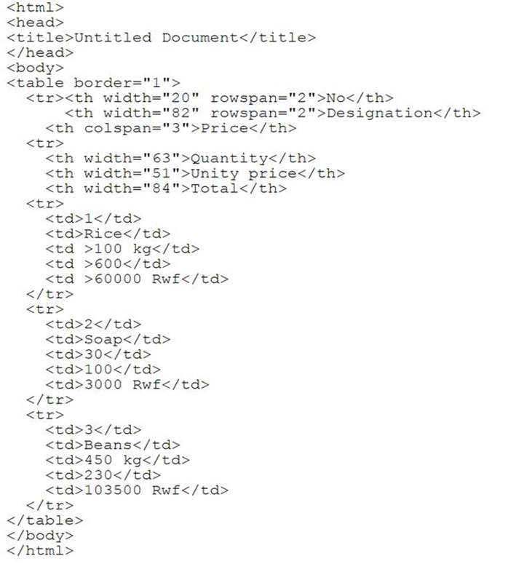16. **Give the result of the following code: 10 marks**